IT24100571

01.

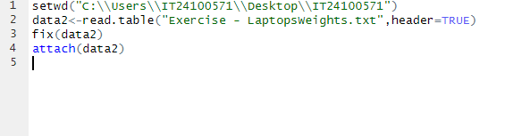

2)

3)

